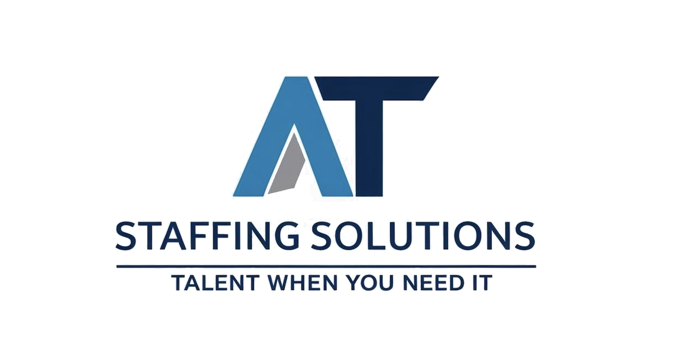

# Quality Policy

Document Ref: QP-001 | Version: 1.0 | Effective: 28 May 2025 | Review: 28 May 2026

AT Staffing Solutions, operating under ATW Safety Logistics Ltd, is committed to delivering reliable and compliant staffing solutions across the UK.

To ensure ongoing customer satisfaction and regulatory compliance, we commit to the following:

- Ensuring all candidates are screened, vetted, and qualified

- Transparent and responsive communication with clients

- Continuous improvement through periodic internal reviews

- Legal and regulatory compliance with UK employment laws

- Training and development of staff and internal systems

This policy provides a framework for setting and reviewing measurable quality objectives. It is communicated internally and made available to relevant external parties.

Approved by:

Jessica Takawy - Director

Date: 28 May 2025